Online Shopping Store Project

Phase I
Develop a scenario for the three (3) identified quality factors. Explain how to test each quality factor for the client-server web application in the space provided. You may add pages if necessary.

Quality Factor: Time Behavior
- Source of Stimulus: End User/Customer interacting with online shopping application.
- Stimulus: User/customer does an action such as selecting an item, adding to the cart, or checking out.
- Environment: Normal Operation (The system shouldn’t have any issues responding to the customer actions under normal conditions).
- Artifact: Online shopping system (such as the clothing selection, the checkout, and virtual fitting-room).
- Response: The system processes the information and completes the requested within 20-30 seconds.
- Response Measure: Operations are completed within 20-30 seconds under normal load for the customer queries and checkout.

How to Test Time Behavior
Simulate customer actions such as product searches, cart updates, opening multiple tabs, and checkout processes. Measure response times of the varying actions, ensuring that the system meets the 20-30 second response time requirement. Performance tests should be conducted during peak hours, 10/11 AM in the morning and 8/9 PM evening, to identify and mitigate issues.

Quality Factor: Confidentiality
- Source of Stimulus: Customer enters in personal information, payment details, or shopping history into website.
- Stimulus: Customer submits sensitive data such as their address, contact information, or payment information.
- Environment: Normal Operation (The data’s confidentiality and integrity should be upheld and handled securely to prevent leaks).
- Artifact: Customer’s personal information and payment data will be stored in the database.
- Response: Customer’s personal information and payment data will be encrypted and carefully handled by the system.
- Response Measure: Customer data will be confidential and data integrity will be kept.

How to Test Confidentiality
Simulate logging in with wrong credentials to confirm if unauthorized access blocking is working properly. Check to see if sensitive information such as passwords are hidden/encrypted during the transfer. Emulate making purchase orders and user updates to check for system consistency, as well as if the information is being stored properly within the system.

Quality Factor: Recoverability
- Source of Stimulus: Either the main system or third-party systems (credit card payment, delivery system, or email system) fail.
- Stimulus: System/service failure (such as if failure in the credit card payment system, a shipping/handling issue, or email error for confirmations).
- Environment: Normal operating (System should be able to recover within 10 minutes as the system is expected to maintain its 24/7 availability).
- Artifact: Online shopping system and third-party systems (credit card payment system, delivery system, and email system).
- Response: The system identifies failures, backs up services, and restores operations within 10 minutes.
- Response Measure: System recovery must be within 10 minutes, with a high priority in data confidentiality and integrity.

How to Test Recoverability
Simulate crashing/outages by restarting application or disconnecting the database/servers. Monitor recovery time and confirm that the system restores functionality, such as the user sessions or cart items, within the 10-minute recovery window.

Phase II
Draw each diagram according to the online shopping store situation described in the project description. Take a clear screenshot of each diagram and paste them in the corresponding spaces. You may add pages if necessary.

System Diagram
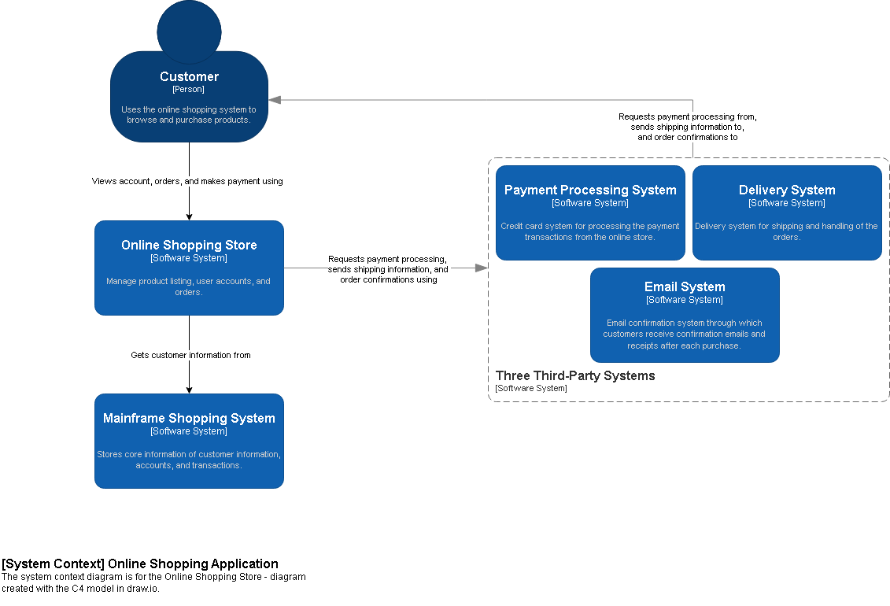

Container Diagram
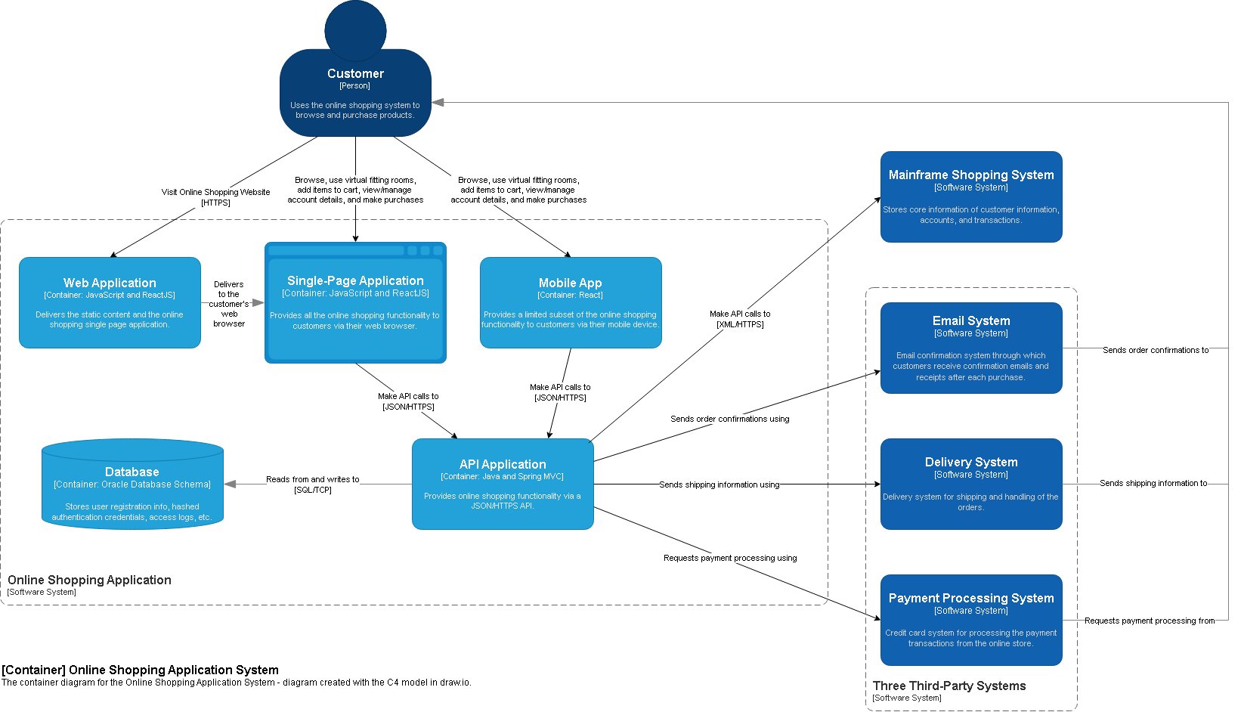

Deployment Diagram
